**Applied Data Science Assignment 1**

**Line Plot:**

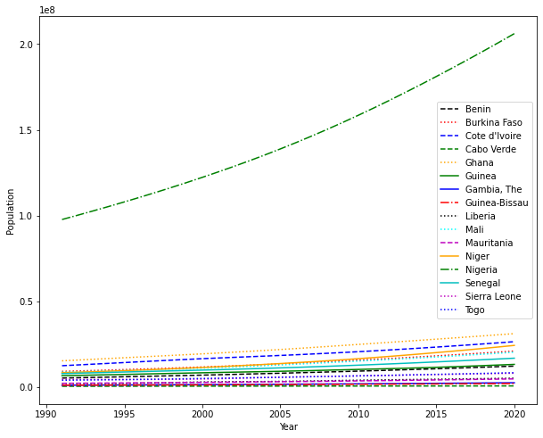

The data set is the population of 16 West African countries and the line plot is showing the population growth from 1991 to 2020. The plot shows a straight-line graph depicting increase in population over the years for the countries. From the graph, Nigeria clearly has the largest population in West Africa and has a steep gradient of population growth. The remaining 15 countries also experienced growth. The population of Ghana and Cote d’Ivoire increased at a gradual rate. Cabo Verde has an insignificant population increase over the span of the captured years.

**Bar Chart:**

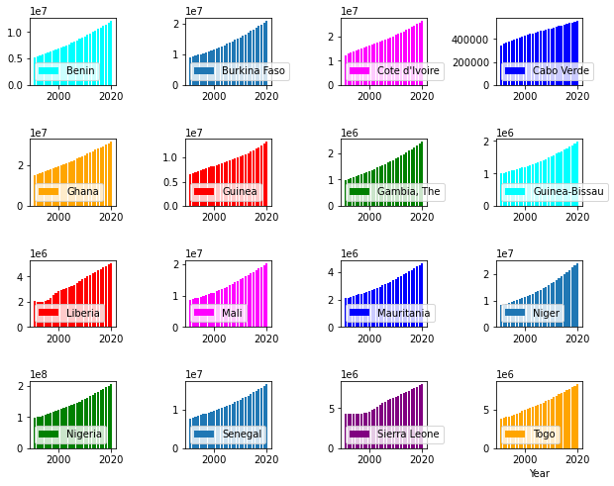

I chose bar chart for the subplots to represent the increase in population. With the bar chart the gradients of the graphs are well represented. A population rise is observed for most of the countries like Niger, Nigeria, Mali, Gambia, Guinea and Liberia. Cabo Verde has a gentle slope showing gradual population growth for Cabo Verde. Sierra Leone has a flat population growth between the years of 1991 and 2000, and thereafter there was a visible population increase.

**Pie Chart:**

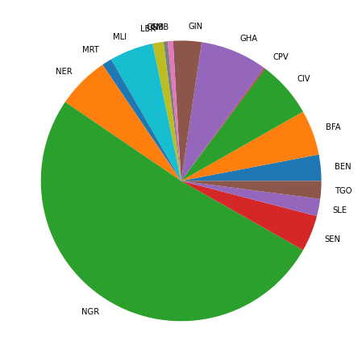

The data set for the Pie Chart is the population of the 16 West African countries for the year 2020. Pie chart is a good representation of proportions. In a glance one could visualize Nigeria with 50% of the total population of West African countries in the year 2020. I chose Pie Chart because it is an excellent tool for visual comparison, and for display of percentage of a proportion relative to the total. The population of Cabo Verde in 2020 was the least.

Data Source: World Development Indicators

<https://data.worldbank.org/indicator/SP.POP.TOTL>

Link to my repository

[ebereinyiama (github.com)](https://github.com/ebereinyiama)